Data Analytics Platform – Comparison of Merge Sort and Quick Sort Using Divide and Conquer

Description of the Real-World Problem
A data analytics platform processes huge amounts of data collected from customers, websites, IoT devices, and business transactions. Before generating reports and visualizations, the data must be sorted quickly and accurately.
Since the datasets can contain millions of records, choosing the right sorting algorithm is important. The algorithm should provide high performance while minimizing execution time and resource usage.
This case study compares Merge Sort and Quick Sort to determine which algorithm is more suitable for a large-scale data analytics platform.

Problem Statement
Design an efficient sorting solution for a data analytics platform that processes large datasets.
The solution should:
- Sort data efficiently.
- Handle very large datasets.
- Reduce processing time.
- Use system resources effectively.
- Produce accurate and reliable results.

Algorithm Used

Selected Algorithm: Merge Sort
Merge Sort follows the Divide and Conquer strategy.

Steps
- Divide the dataset into two equal halves.
- Continue dividing until each subarray contains one element.
- Merge the subarrays in sorted order.
- Continue merging until the complete dataset is sorted.

Justification for Choosing the Algorithm (Why Merge Sort?)
Merge Sort is selected because:
- Provides guaranteed O(n log n) performance.
- Performs consistently for both small and large datasets.
- Stable sorting algorithm.
- Suitable for external sorting where data cannot fit entirely in memory.
- Works efficiently with linked lists.
- Handles large business datasets reliably.
Although Quick Sort is usually faster for smaller datasets due to cache efficiency, its worst-case performance is O(n²).

Complexity Analysis
Algorithm | Best Case | Average Case | Worst Case | Space Complexity | Stable
Merge Sort | O(n log n) | O(n log n) | O(nlog n) | O(n) | Yes
Quick Sort | O(n log n) | O(n log n) | O(n²) | O(log n) | No

Manual Execution (Step-by-Step Process)
Suppose the dataset is:
45 23 67 12 89 34

Step 1
Divide
45 23 67 | 12 89 34

Step 2
Further Divide
45 | 23 67

23 | 67

12 | 89 34

89 | 34

Step 3
Merge
23 67

23 45 67

34 89

12 34 89

Step 4
Final Merge
23 45 67

12 34 89
Merge both
12 23 34 45 67 89
Final Sorted Output
12 23 34 45 67 89

Advantages

Merge Sort
- Guaranteed O(n log n)
- Stable sorting
- Suitable for large datasets
- Parallel processing possible
- Efficient for external storage

Quick Sort
- Very fast average performance
- Requires less additional memory
- Cache friendly
- Simple implementation

Applications
Merge Sort
- Database management systems
- Data analytics platforms
- External sorting
- Cloud computing
- Big data processing
- Linked list sorting
Quick Sort
- In-memory sorting
- Operating systems
- Library sorting functions
- Real-time applications

Limitations

Merge Sort
- Requires extra memory O(n)
- More memory overhead
- Slightly slower for small datasets

Quick Sort
- Worst-case O(n²)
- Not stable
- Performance depends on pivot selection

Comparison with Other Algorithms
Feature | Merge Sort | Quick Sort | Bubble Sort | Selection Sort
Technique | Divide & Conquer | Divide & Conquer | Comparison | Comparison
Best Case | O(n log n) | O(n log n) | O(n) | O(n²)
Average Case | O(n log n) | O(n log n) | O(n²) | O(n²)
Worst Case | O(n log n) | O(n²) | O(n²) | O(n²)
Stable | Yes | No | Yes | No
Extra Memory | O(n) | O(log n) | O(1) | O(1)
Suitable for Large Data | Excellent | Good | Poor | Poor

Sample C Program

#include <stdio.h>

void merge(int arr[], int l, int m, int r)

{

int i, j, k;

int n1 = m - l + 1;

int n2 = r - m;

int L[n1], R[n2];

for(i = 0; i < n1; i++)

L[i] = arr[l + i];

for(j = 0; j < n2; j++)

R[j] = arr[m + 1 + j];

i = 0;

j = 0;

k = l;

while(i < n1 && j < n2)

{

if(L[i] <= R[j])

arr[k++] = L[i++];

else

arr[k++] = R[j++];

}

while(i < n1)

arr[k++] = L[i++];

while(j < n2)

arr[k++] = R[j++];

}

void mergeSort(int arr[], int l, int r)

{

if(l < r)

{

int m = (l + r) / 2;

mergeSort(arr, l, m);

mergeSort(arr, m + 1, r);

merge(arr, l, m, r);

}

}

int main()

{

int arr[] = {45,23,67,12,89,34};

int n = 6;

mergeSort(arr,0,n-1);

printf("Sorted Array:\n");

for(int i=0;i<n;i++)

printf("%d ",arr[i]);

return 0;

}

OUTPUT

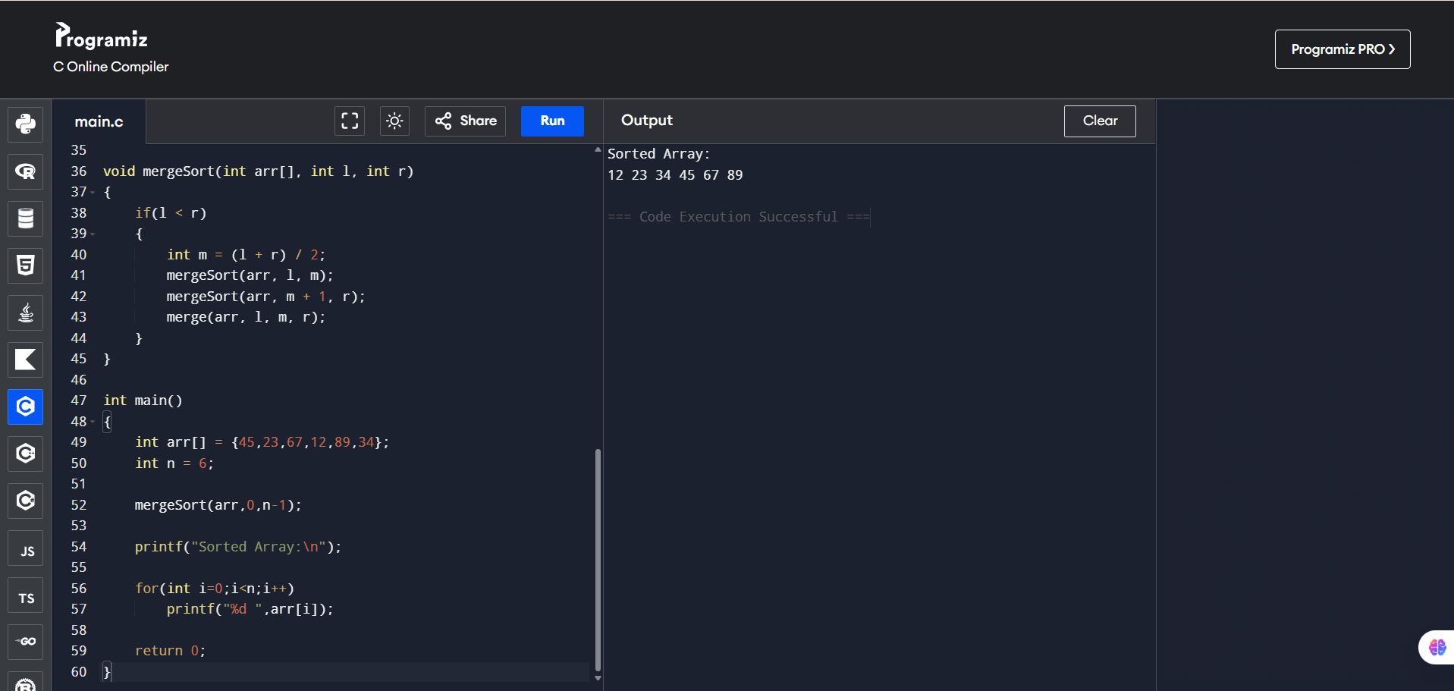

Conclusion
For a data analytics platform, Merge Sort is the preferred algorithm because it guarantees O(n log n) performance regardless of input data. It is stable, reliable, and ideal for processing large datasets where consistent execution time is more important than minimizing memory usage.
Quick Sort is faster in many average cases and uses less extra memory, making it a strong choice for in-memory datasets. However, its potential worst-case O(n²) time makes it less predictable for large-scale analytics workloads.

